**Name: Smeet Parmar – 8897851**

**Course: Web Development [SEO]**

**Keyword Research and Content Development on -** [**https://www.muvez.co/**](https://www.muvez.co/)

* **Introduction**:

Muvez footwear slipper shoes were featured in shark tank season 11. Main aim of the site is to make a shoe which have a which is detachable like thing at bottom and can be also used as shoes without removing sole and can also be used after removing the sole.

* **Site structure**:

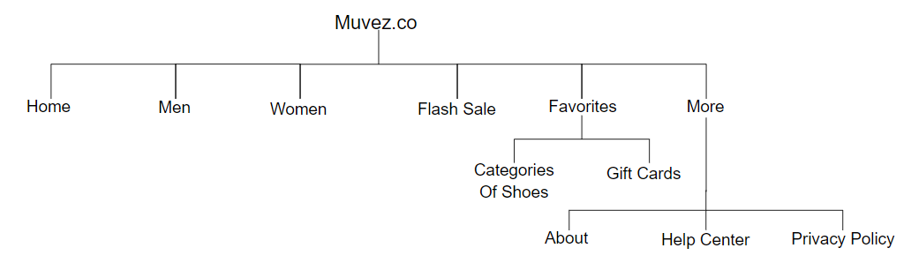

This is old site structure where it is not properly categorized and is not evenly organized. As you can see you have men and women category as main item and in flash sale you have all categories and inside favorites you also have all categories. Which also includes other category of Women + Kids. And gift cards page is inside favorites which is odd according to me.

And one another thing which I noticed during audit is the site do have a blogs page but it is not visible in site it is just page for crawling it is not visible to users. Lastly, inside more they have about which should be a main topic.

According to my perspective the site should have followed this structure: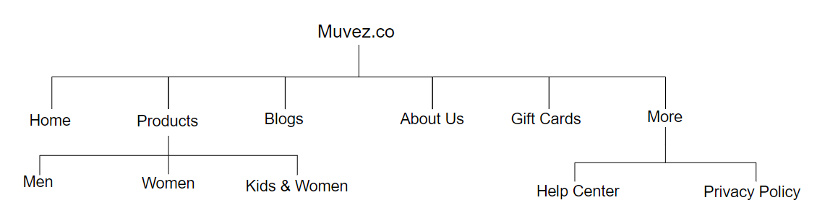

So, in new structure it should have main topics i.e. home, products inside products it should have their categories, then comes blog, about us, gift cards and more, inside more they can have help center and privacy policy. Flash sale is not required I guess because it is showing combination of all products nothing else. This structure is more user friendly and SEO friendly compared to old site structure.

* **Potential keywords related to page and its content:**

**1. Home Page:**

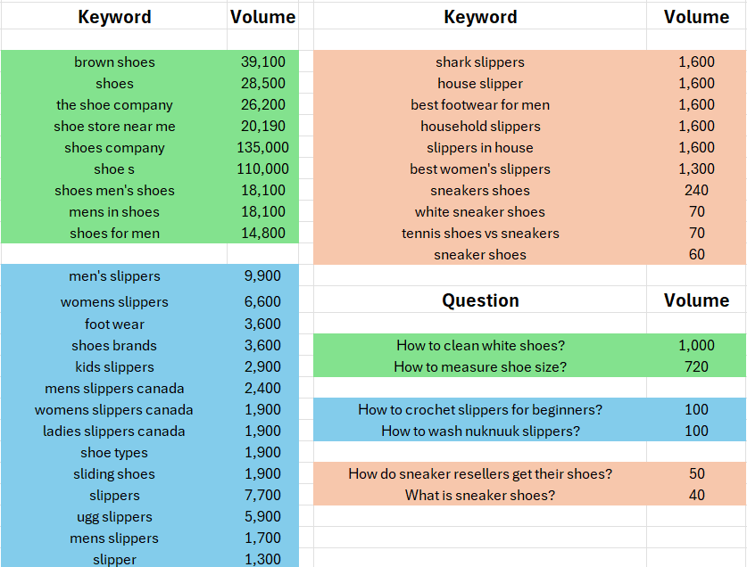

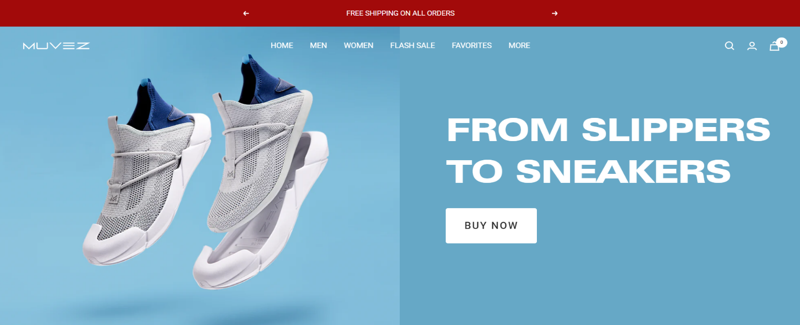

Firstly, in slider there is a heading “From Slippers to Sneakers”. Which is not ideal. It should have a little bit content in it like "From Slippers to Sneakers", Slippers and sneakers merge comfort and style, reflecting both tradition and innovation in footwear. They transition from cozy indoor wear to versatile outdoor fashion staples, embodying relaxation, and active lifestyles seamlessly. Images in sliders should have alt tag as “Slipper and Sneakers.”

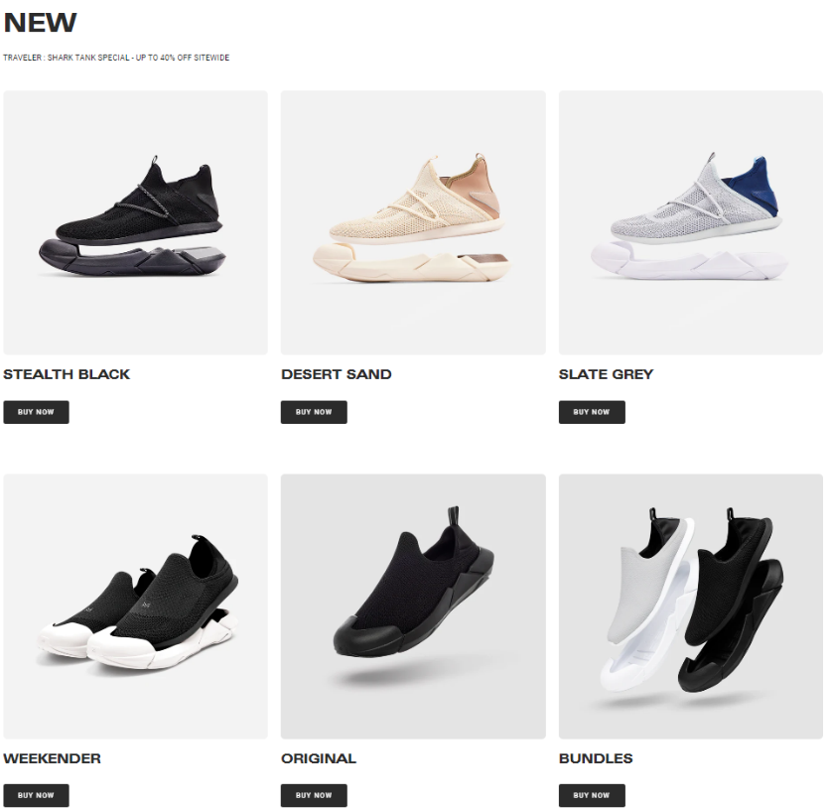

Secondly, these all products should have a little bit description. Like stealth black product should have a little bit of its description - Stealthy black shoes blend elegance and slipper-like comfort, transcending boundaries between formal footwear and cozy loungewear, ideal for versatile styling. Their sleek design effortlessly complements any outfit, ensuring both sophistication and comfort throughout the day. Also the image of this product should have alt tag as “Stealth Black Shoes”.

Desert Sand - Desert sand-colored shoes evoke warmth and versatility, harmonizing with various outfits while embracing the serene essence of nature's hues. Crafted for comfort and style, they seamlessly transition from casual outings to elegant occasions, adding a touch of refinement to every step. The image should have alt tag as “Desert Sand Shoes”.

Slate grey - Slate grey shoes exude sophistication and seamlessly complementing any ensemble with their understated elegance and timeless appeal. Versatile and chic, they effortlessly elevate your look, making them a must-have addition to any wardrobe. The image should have alt tag as “Slate Grey Shoes”.

Weekender - Weekender shoes for men – a perfect for relaxed weekends with family and friends, yet equally sharp for stepping into corporate meetings. Their versatile design ensures comfort and style, transitioning seamlessly between casual and formal settings, making them an essential wardrobe staple. The image should have alt tag as “Weekender Men Shoes”.

Original - Introducing the Original Shoe: A fusion of traditional footwear with detachable slippers, offering both style and comfort for every occasion. Versatile and innovative, they provide the convenience of slip-on comfort with the sophistication of classic shoes, making them a go-to choice for modern lifestyles. The image should have alt tag as “The Original Muvez Shoes”.

Bundles - Elevate your footwear game with our unique pairing of sleek shoes and detachable cozy slippers, offering ultimate versatility. This bundle combines style and comfort, providing the perfect solution for all-day wear, whether at home or on the go. The image should have alt tag as “Bundles Muvez Shoes”.

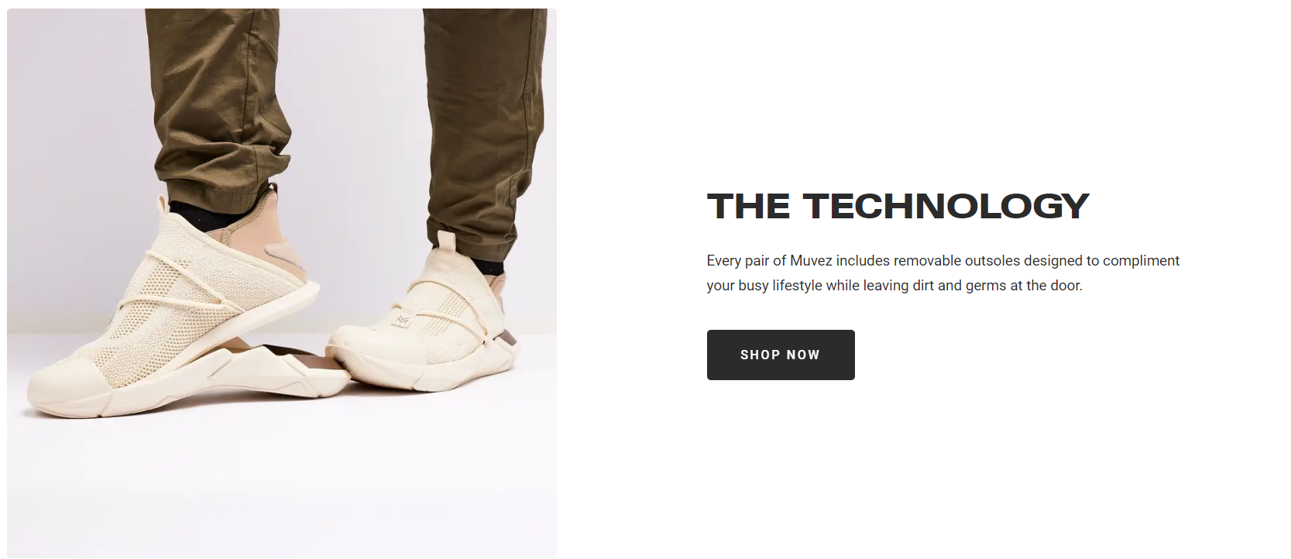

The technology says about working and usage of Muvez shoes. But the content is very less. It should have content like : Every pair of Muvez shoes is meticulously crafted with removable outsoles, seamlessly integrating style with functionality. Designed to cater to your dynamic lifestyle, these innovative outsoles ensure convenience and cleanliness. Simply swap them out to adapt to various environments, whether you're indoors or outdoors. By leaving dirt and germs at the door, Muvez promotes a hygienic living space while offering unparalleled comfort. With this thoughtful design feature, Muvez empowers you to move confidently through your day, from casual outings to formal occasions, without compromising on style or cleanliness. Experience the freedom to step forward with Muvez – where comfort meets convenience. And the video should be a commonly supported browser format.

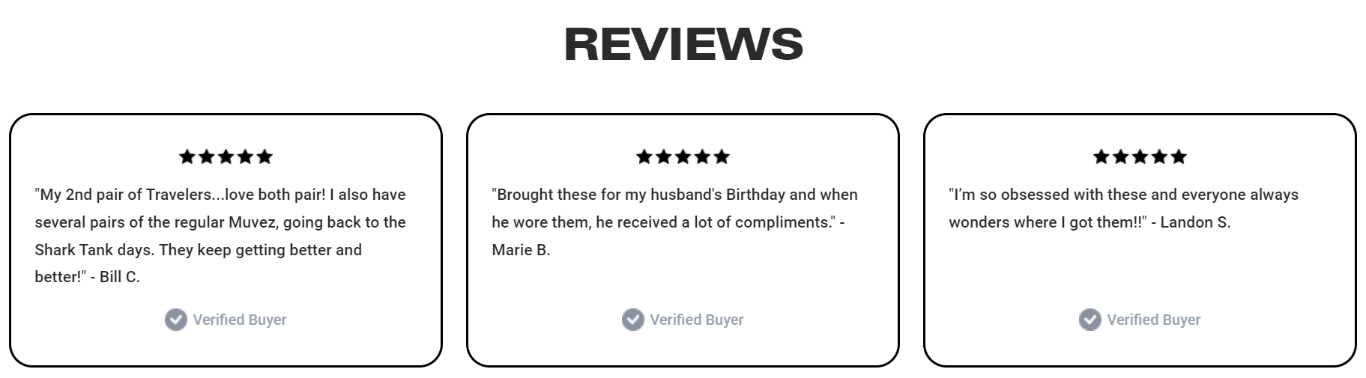

I think reviews are not required in the home page; it should be in about page. Instead, this home page can have FAQ section where they can have 3 – 4 questions and answers, questions should be from list of questions who have high volume. Except these all-other things in home page are correct and makes a proper sense.

**2. Men Shoes Page:**

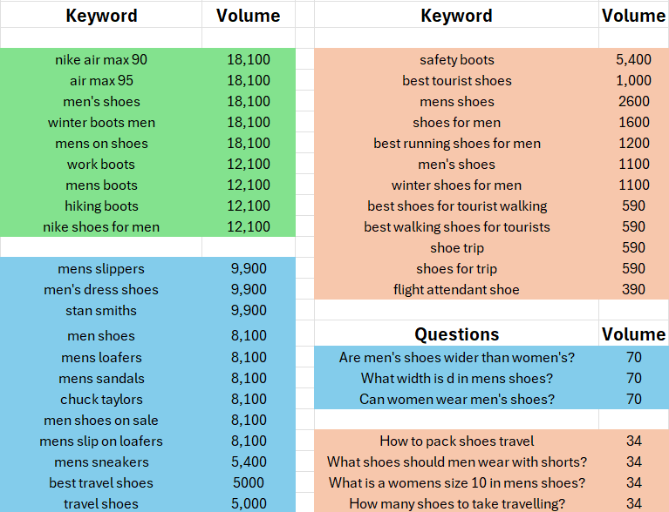

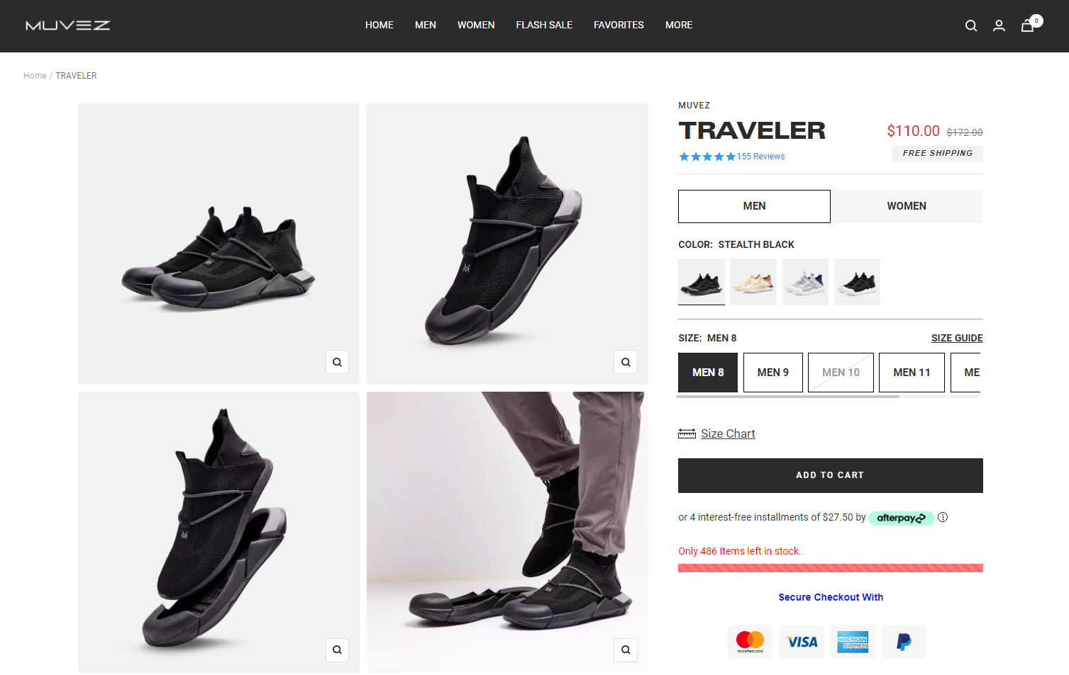

It has a breadcrumb which is great. Then it has traveller heading but it has description at bottom which is not ideal. And other things, all the category shoes have same description. The description should be : “Introducing the Muvez Traveler Collection: A pinnacle of versatility tailored for the contemporary man constantly on the go. Crafted from premium materials and pioneering design, these shoes seamlessly marry comfort, elegance, and practicality. Engineered for the adventurous nomad, Muvez Traveler footwear is featherlight, robust, and effortlessly packable, serving as the ultimate companion for any expedition. Whether traversing bustling metropolises or navigating bustling airports, these shoes guarantee unmatched comfort and stability, ensuring you reach your destination invigorated and prepared for every adventure. Redefine your travel experience with Muvez Traveler shoes – where comfort harmonizes with wanderlust.”

Then It also have 2 categories i.e. is men and women. Which is illogical and unnecessary according to me. Because for men they have “Traveller” category and for women they have “Weekender” category shoes. So, that both categories should be removed from here. Then talking about size here in men they have size Men8, Men9, Men10…. Which doesn’t make sense. In women page they have size as Women8, Women9, Women10… on the other hand in bundle category i.e. kids + women category they have sizes as 8,9,10…

So, to solve this they should have shoe sizes as 8,9,10 and so on in all the pages. Then, they have size chart and size guide which are same they open a common size chart. So, the bottom one which is size chart that must be removed. In all these images they should have an alt tag and inside alt tag they can have keywords like I mentioned above.

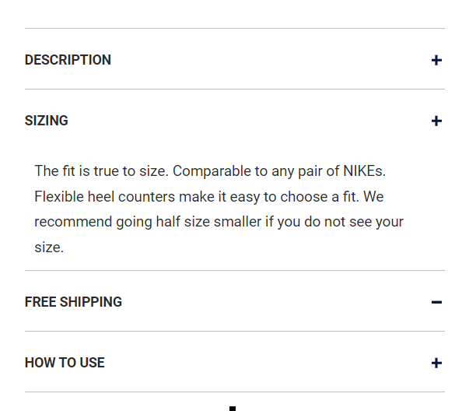

Below add to cart button, site have these 4 items. As we have moved description at top of page with heading there is no need to write again the description. The details of how to measure the size should be below the available sizes not here. And other 2 things i.e. free shipping and how to use can be moved to about us page it is not required here because all 3 products have this 2 things common.

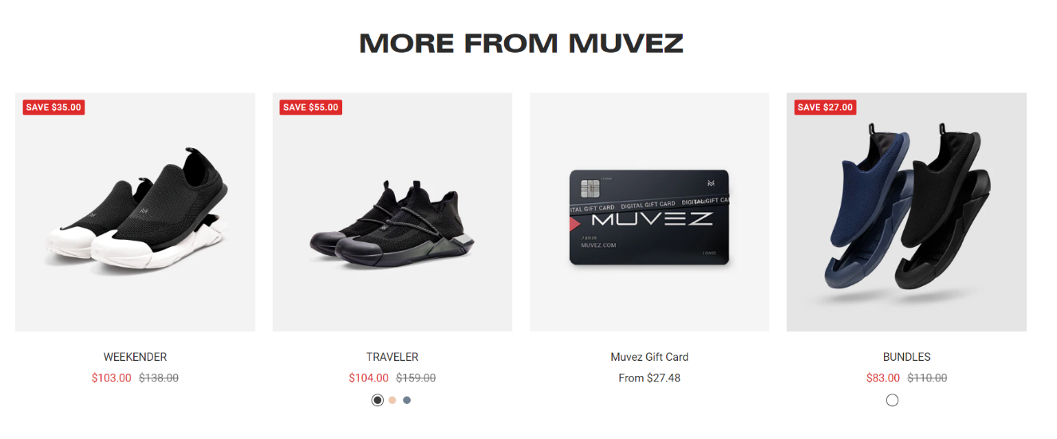

Then site has more from muvez section. Here images and UI is good but content is less. Below weekender product it should have some text like “A perfect pair of shoes for women to enjoy their weekends seamlessly without any interruptions.”. Traveler can have description like “Ideal choice for men which can be used at house as well as for travelling purpose.” Muvez gift card can have description like “This card be used to get instant discount on any shoes sold be muvez.” Bundles can have description like “Matching 2 pair of shoes ideal for multipurpose usage for any person”.

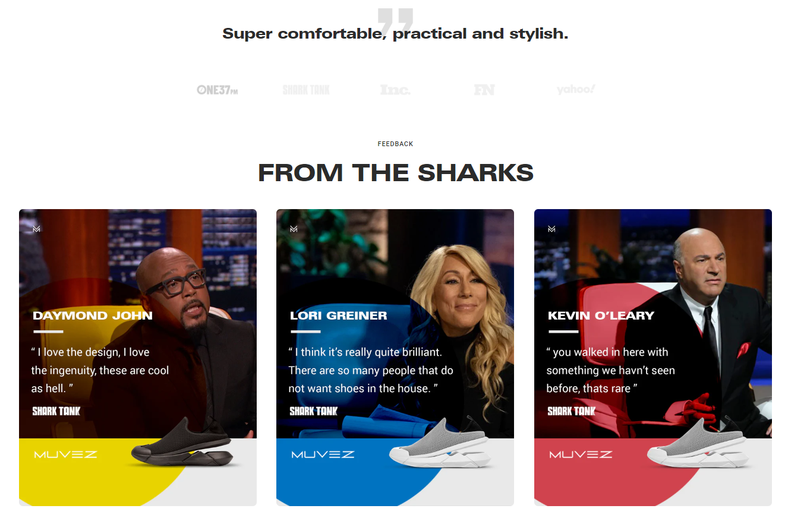

Then it has “Super comfortable, practical and stylish” heading which is awesome, but images below that are not perfect because they all are of different colors they all should be in dark gray or black color which can be easily readable. Also these images should have appropriate alt tags.

The section “From the sharks” can be removed because it is common in all the products pages. Instead it must be in about section. Below it they have information about there is section like, detachable sole, slipper below, machine washable and new soles content which is not required here I guess. It can be placed inside about us page. Also it should be removed because all products page have this same thing.

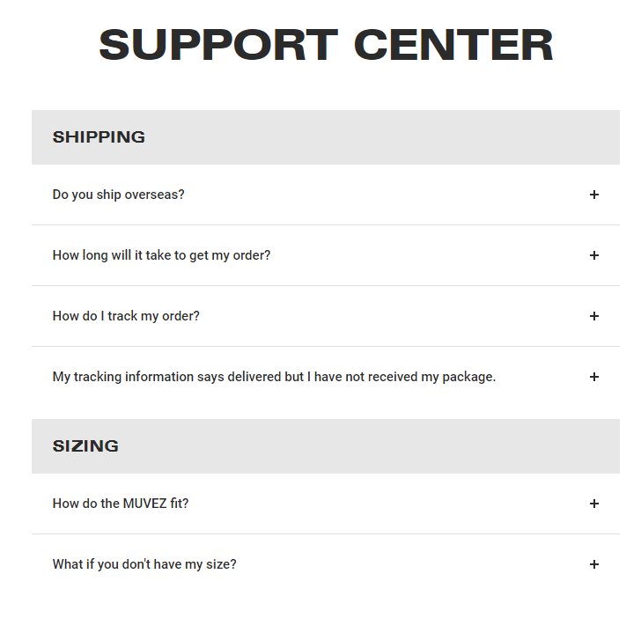

The support section is good like FAQ section. It has good and trending questions but they can also include questions I mentioned above and their answers. Lastly, this page have customer reviews and a bit about gift card which looks good in page. One last thing, they have a infinite scrolling error in this page I don’t know why, which must be fixed anyhow.

**3. Women Shoes Page:**

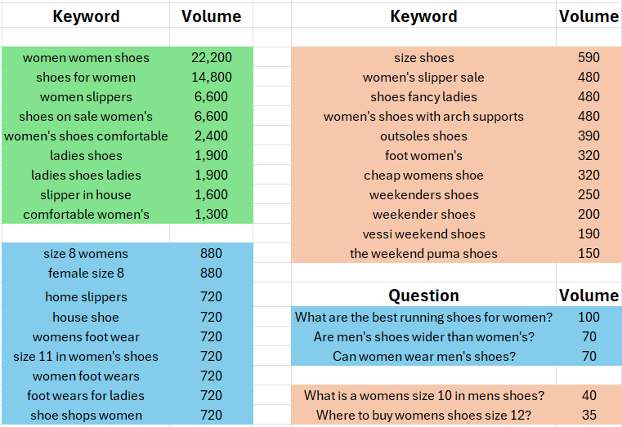

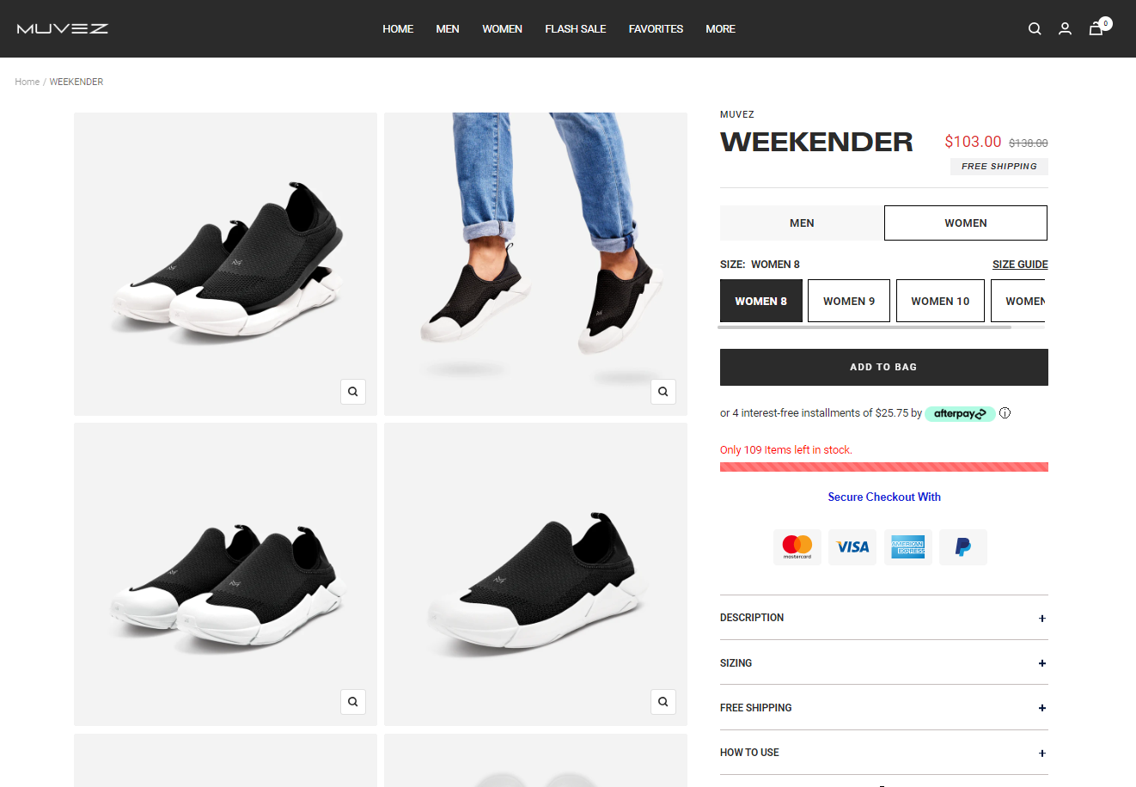

This page is also almost identical to men shoes page i.e. traveler category shoes. And it also has same errors and same solutions as well. Likewise, there should be a description below weekender title i.e. “Introducing the Muvez Weekender Collection for Women: An embodiment of casual elegance tailored to the modern woman's lifestyle. Crafted with premium materials and innovative design, these shoes seamlessly blend comfort, style, and versatility. Engineered for spontaneous weekend adventures or casual outings with friends, Muvez Weekender shoes offer a perfect balance of relaxation and sophistication. Lightweight and easy to slip on, they provide all-day comfort without compromising on style. Whether strolling through the city streets or enjoying a leisurely brunch, these shoes ensure you step out in confidence and style. Elevate your weekend wardrobe with Muvez Weekender shoes – where comfort meets chic femininity.”

Then they should not have men and women category because they are not providing anything different here for men and women. Instead they have different product for men i.e. traveler shoes. Another thing, they are not providing color options here in weekender category which is not good according to good user experience. As they are providing users with different colors on traveler(men) shoe category and bundle(kids+women) shoe category but they are not providing with colors here in this category which should not be case. So, I suggest that they should add colors to it and users should be able to select the colors. Same case is with size as men they should have common sizes i.e. 8,9,10 and so on. A small thing I noticed that in traveler and bundle category they have a button on “Add to cart” while here in weekender category they have “Add to bag” button which is quite awful. They should have add to cart button here as well.

Then free shipping and how to use should be moved to about us page. And information regarding sizing should be moved up below sizes. Afterwards they have more from muvez section which should be updated as I suggested above in men shoes page. Then it has all same content like men page. As a result, “more from muvez” section can be updated, “from the sharks” and other 4 section where there is information about technology can be moved to about us page. Gift card and customer review section looks good. Lastly, it has support section which has same questions as men page, Instead they can have some trending questions and suggestion can be from above mentioned questions. This page also have that infinite scrolling issue which needs to be fixed.

**4. Kids + Women Shoes Page:**

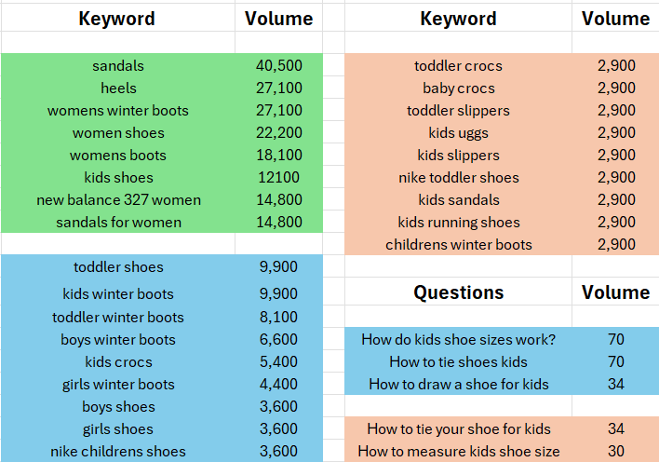

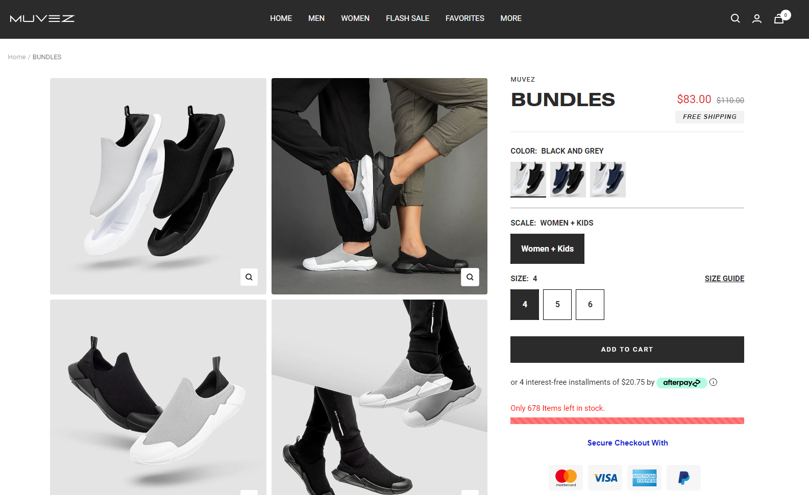

The bundle page is also similar to traveler and weekender pages. So, same changes implies to this page. Below bundle title there should be description like “Introducing the Muvez Bundle Collection for Kids and Women: A fusion of style and convenience crafted to meet the diverse needs of active families. These shoes offer unparalleled versatility, combining sleek designs with detachable cozy slippers for all-day comfort. Whether running errands, playing in the park, or relaxing at home, Muvez Bundle shoes provide the perfect balance of fashion and functionality. With their easy-to-swap outsoles, they ensure cleanliness while accommodating the dynamic lifestyles of both kids and women. Step into comfort and style with Muvez Bundle shoes – where practicality meets playful elegance.”

Then I don’t know what is meaning of “Scale: Women + Kids”. Because men and women category doesn’t have the scale thing. So, I think that must be removed to have similarity and same flow in site. Also it is required to maintain modularity across site. The sizes should have more options as they are also for women. Then free shipping and how to use should be moved to about us page. And information regarding sizing should be moved up below sizes. Then it has all same content like men page. As a result, “more from muvez” section can be updated, “from the sharks” and other 4 section where there is information about technology can be moved to about us page. Gift card and customer review section looks good.

At the end of page it has some video reviews, I don’t know why there are in this page they should be moved to about us page from here. It also has support section with same questions as all other pages which should be updated. If possible more from muvez should be modified and it can be same as other product pages to maintain modularity in code. Surprisingly, it doesn’t have that infinite scroll issue which is great.

**5. Gift Card Page:**

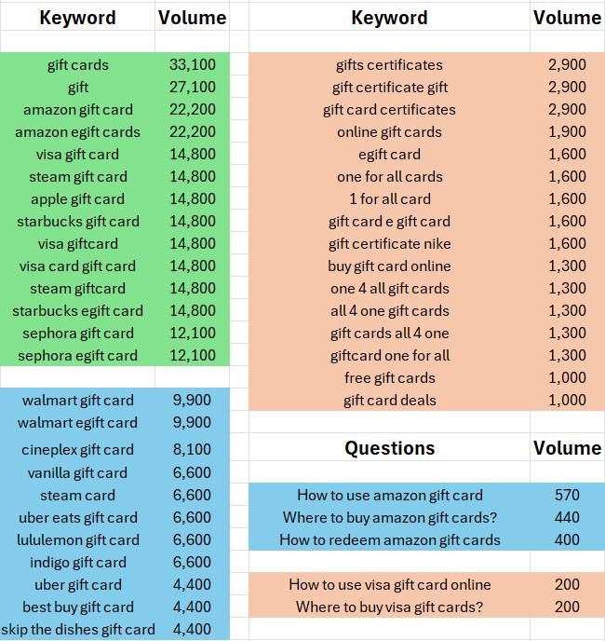

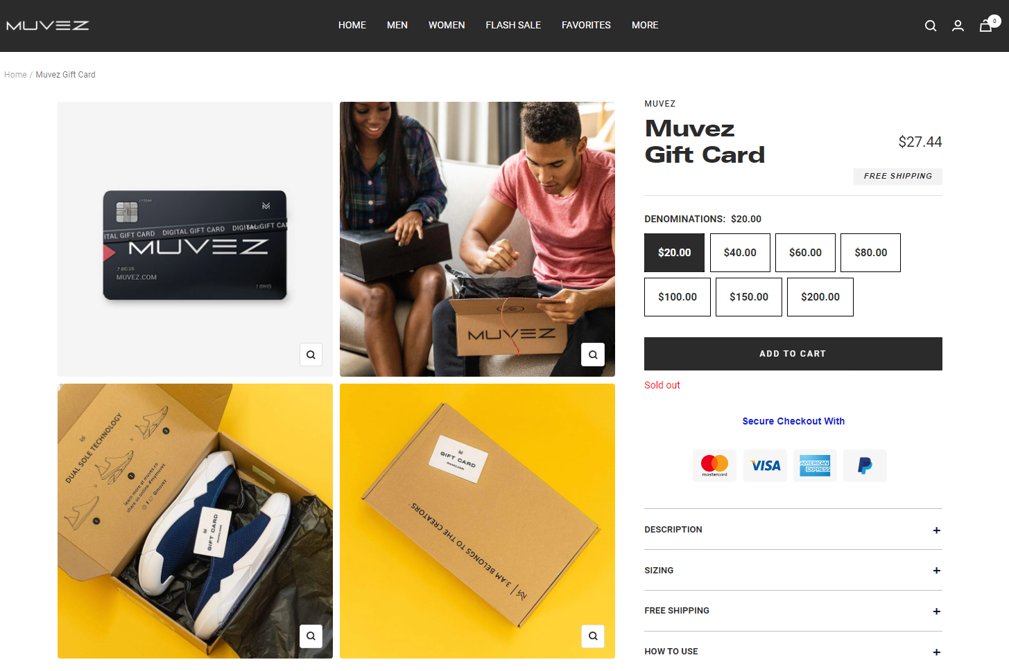

The gift card is almost same like products page but it has some unnecessary things on page. Like, in image above you can see that it has sizing tab, which is irrelevant here, because in gift card you cannot have size section. So, size can be removed. Free shipping and how to use can be moved to about us page. And description is same as products which needs to be changed, and need to be below Muvez Gift Card heading.

Description should be “Indulge your loved ones with the Muvez Gift Card, an impeccable choice for those who prioritize both comfort and style. With our versatile card, recipients have the freedom to handpick their perfect footwear from our diverse collection. Whether it's for a birthday celebration, holiday surprise, or any special occasion, this gift ensures they experience the unmatched joy and satisfaction that comes with owning a pair of Muvez shoes. Give them the gift of choice and elevate their comfort and style game with Muvez.”

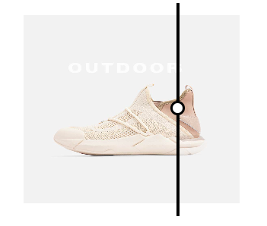

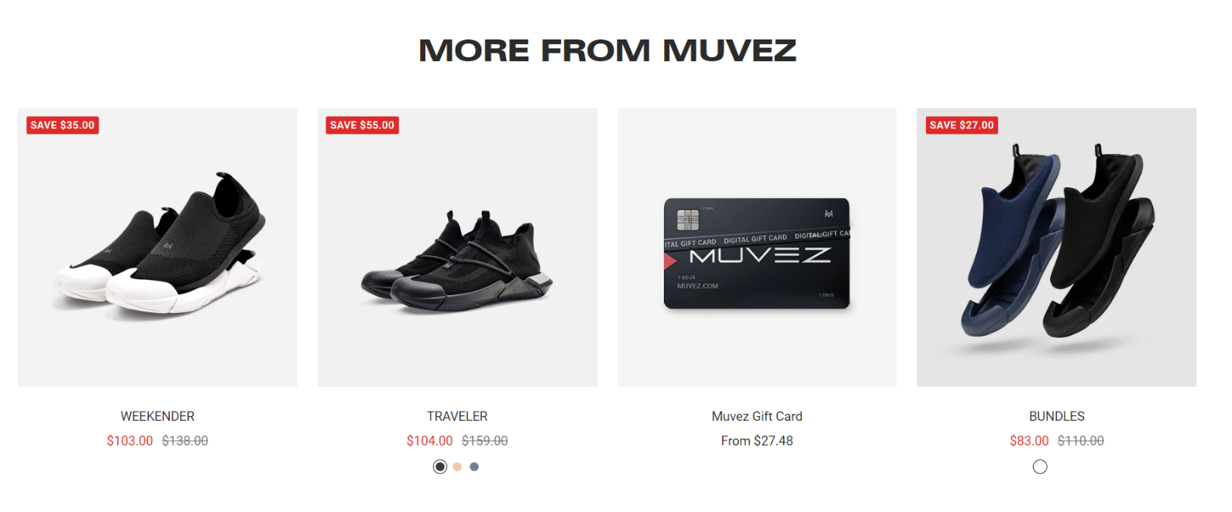

Then it has a small section which shows you difference of shoes with sole and after removing detachable sole. Which is not required here as it is in products page but here in gift card page it is not at all required. And same with “more from muvez” section, it should have content in it like I mentioned in men page. Then it has “from the sharks” section which can be moved to about us page. Other 4 section where there is information about technology can also be moved to about us page.

It also has support section with same questions as products page which is not good. Instead they should have different questions related to their gift card and their usage. I also mentioned some questions above, they can use them as well.

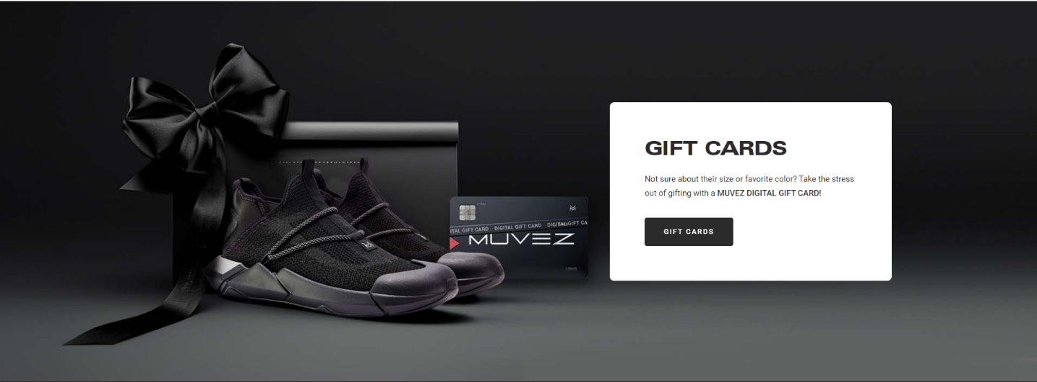

They have gift section which is some small info about gift card which is irrelevant as this whole page is about gift card and we mentioned its description above here this section is not required and should be removed. One last things about this page, it also has that infinite scrolling issue that must be fixed anyhow.

**6. About Us Page:**

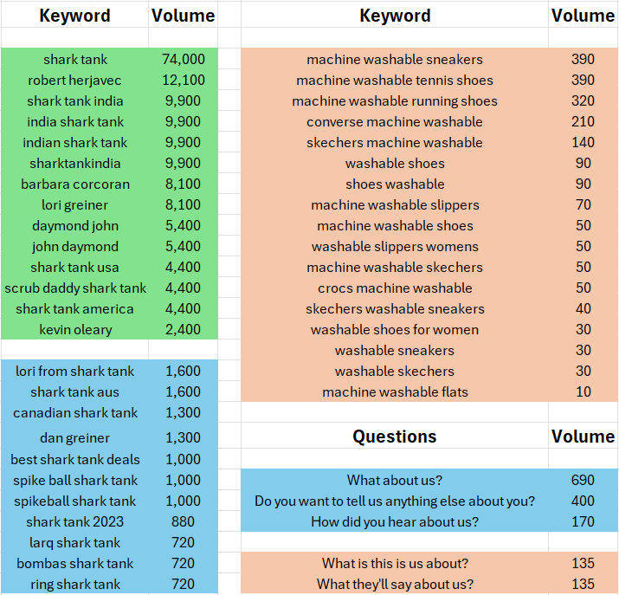

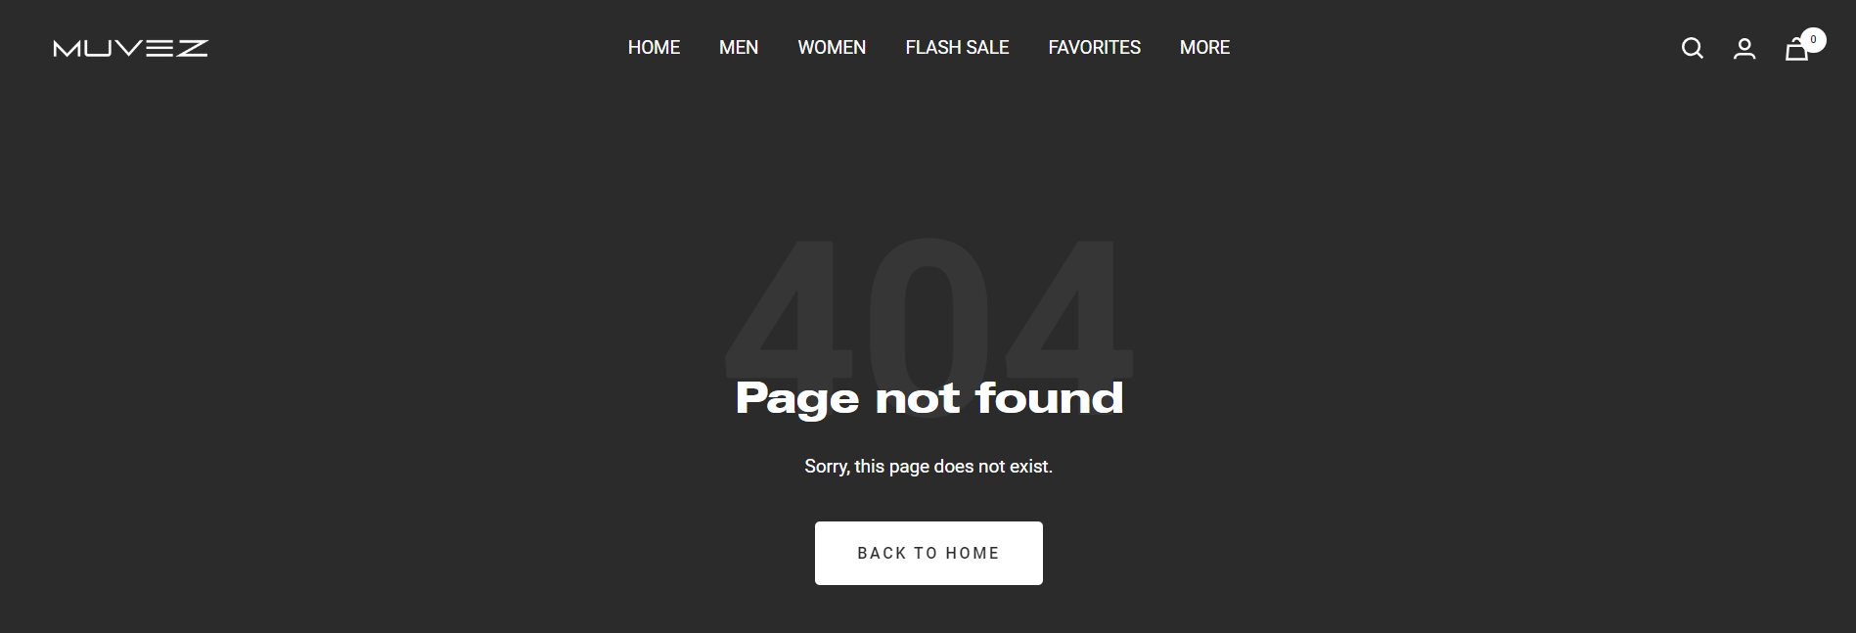

Surprisingly this page is not found which is very bad. As each website should have a about us page showing all information about company and its evolution. Firstly, it should have h1 heading like “Evolution of Muvez” or “Our Story” and a little but content about it like photo below…

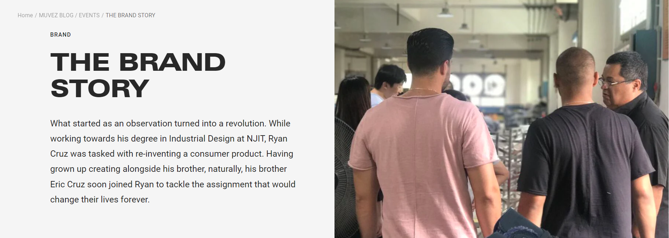

Then it should have a button with text “Read More”, which should redirect them to their blog, they have a big blog regarding their evolution from scratch. After this section they can have main section, as they were featured in shark tank they should have the section like below..

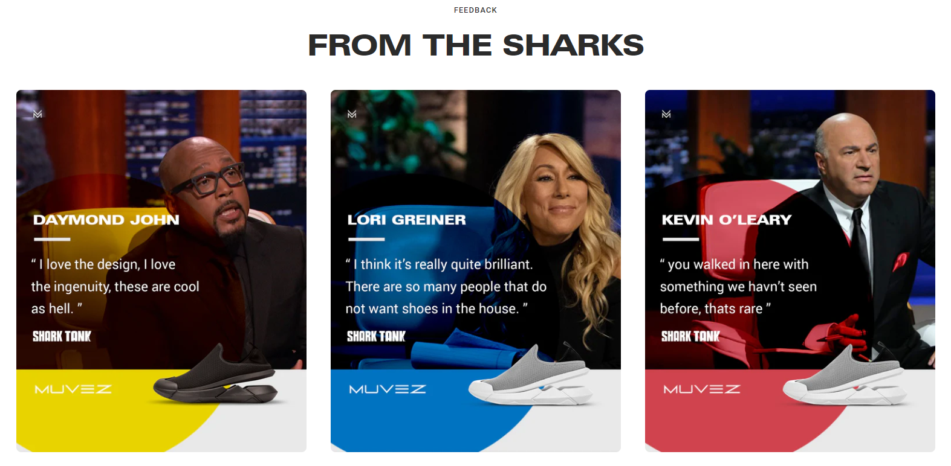

Each of this should redirect user to their respected blog which should have information about sharks and what they said in their pitch which full episode link. As this is the main section with help of which they can gain popularity and sell more shoes. Afterward they can have features of their innovative technology like images below…

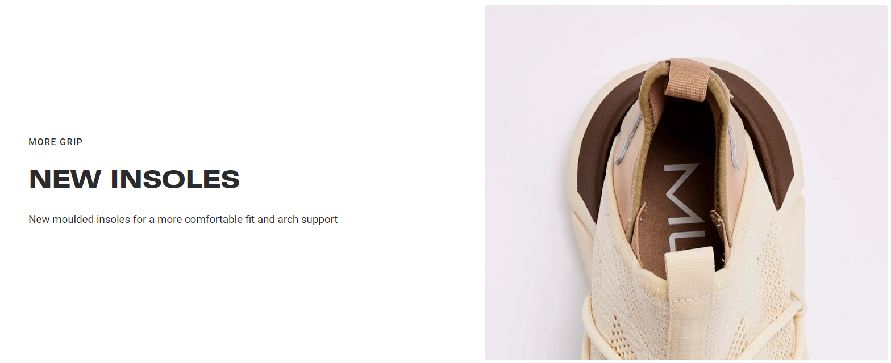

It can have more descriptive content like this “Our shoes now offer superior traction, ensuring stability and confidence with every step. Experience unparalleled comfort with our redesigned insoles. Engineered for a perfect fit and enhanced arch support, they provide ultimate cushioning and support for all-day wear. Upgrade to Muvez and feel the difference.”

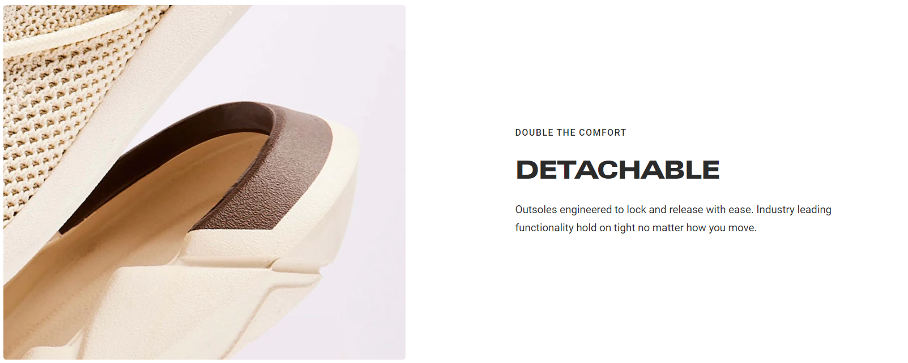

It should have more description like “Our detachable outsoles are engineered for seamless locking and release, ensuring industry-leading functionality. Experience unrivaled stability and freedom of movement with every step. One of the main functionality of our shoes that you can have a detachable sole which you can detach at home or indoors and can re attach the same for outdoor activities. Resulting this it provides comfort at both the places i.e. indoors and outdoor with stylish shoes.”

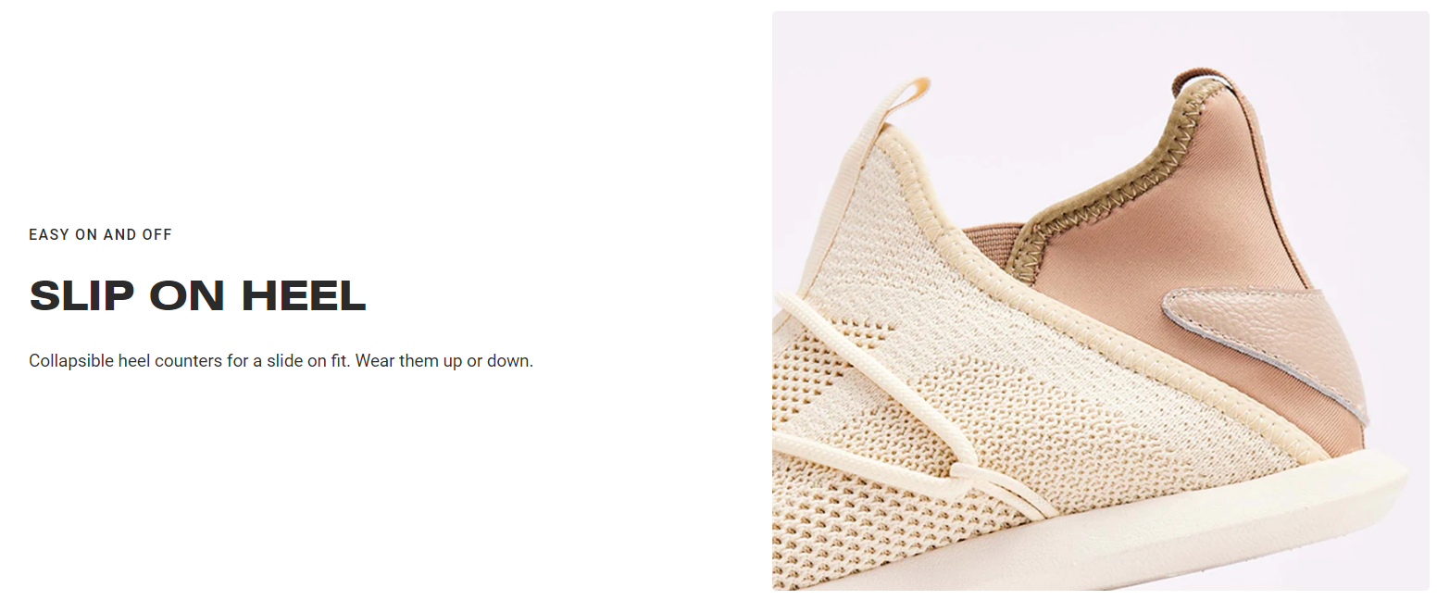

The easy on and off can have more description like “Experience effortless convenience with Muvez: Our Slip-On Heel design ensures easy on and off functionality, while collapsible heel counters provide a snug fit. Versatile wear options allow you to effortlessly transition from casual to formal, making Muvez the perfect choice for any occasion. Plus, with easily removable soles, customization and maintenance are a breeze.”

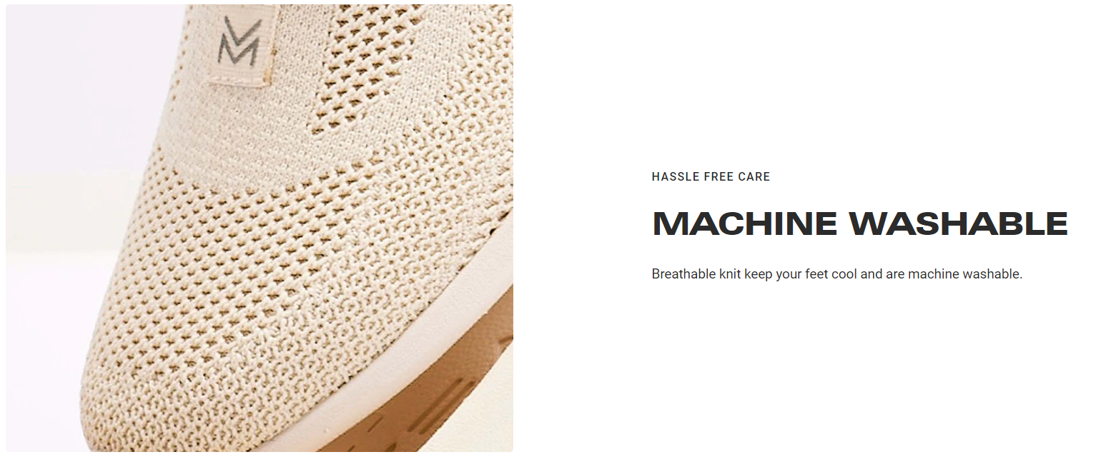

This part can also have more description like “Our shoes prioritize convenience: They're machine-friendly, allowing you to wash them whenever and wherever you please. Both the shoes and soles are washable, offering ease in cleaning options. You can use detergent or cleaning liquid to ensure they're dirt-free, and they dry quickly, ready for reuse for any purpose.” Below this they can add a small section about their services like the image below…



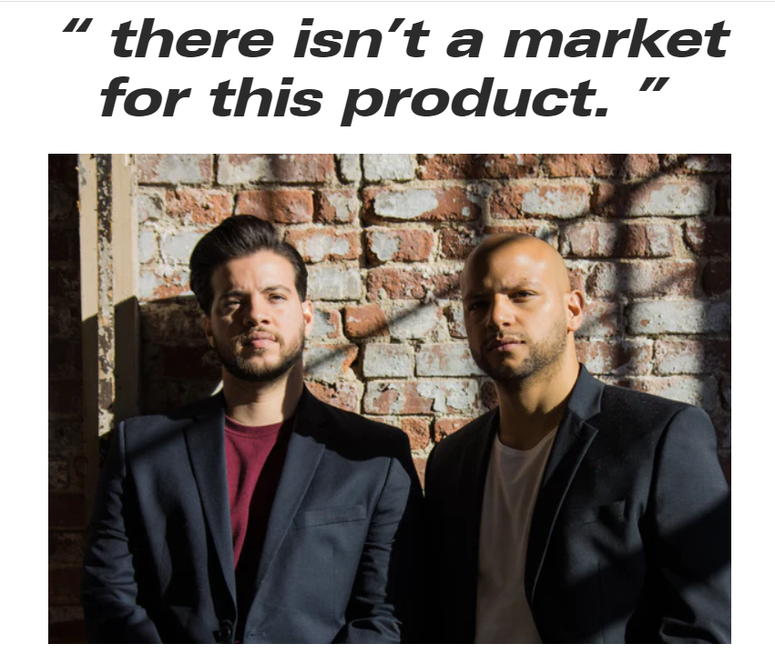

After that they can have other section with heading “Our Team”. They can have their founder’s and teams photos like above and a little bit description about them. And at last they can have that small introduction about gift cards which I suggested to be removed from gift card page.

**7. Blogs Page:**

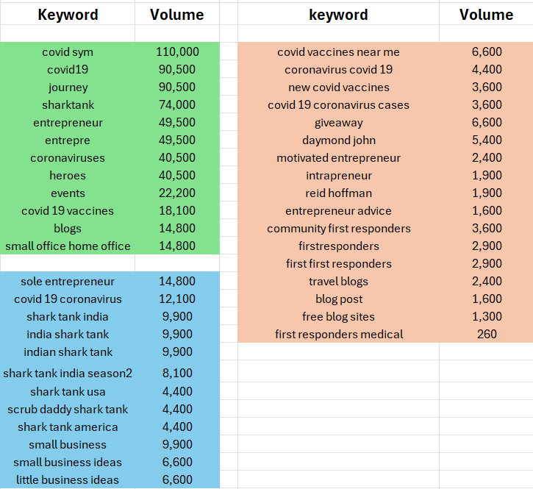

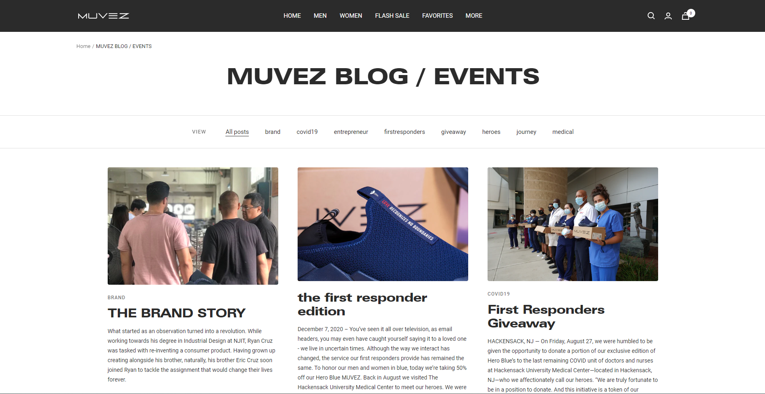

This is link for their blog page <https://www.muvez.co/blogs/muvezblog> . Shockingly, from the site we cannot go to blogs because there is no link for going to blogs page. I guess they don’t have it because they earlier used to have blog but now they have decided to not show it to clients. So, they should a main menu item names blogs, which redirects user to this page. The blogs page do not that much errors like other pages. But it has some. Firstly all the content of blogs displayed in blogs page are not of same size like every item is of different height which doesn’t look good. Instead they can have a similar number of words in content like they can have 200 words in main page and when user click on blog it should have all the content of blog. Currently, when I click on blog it have same content as it is displayed in blogs page.

Other thing, not all the blogs have category in it. For example, in above image brand story blog has “brand” as category but second blog doesn’t have any category so my suggestion is all blogs should have categories. Also content of blog should be justified, currently it is aligned left. Implementing all these things will make blogs page look appealing and attractive. Also, all the images in this page should have a appropriate alt tags with proper keywords. Lastly, currently there are not enough blogs related to events to be specific there are just 9 blogs currently. Instead they should have added more blogs repeatedly to boost site. This page also have filter according to category which is good.

**8. Help Center Page:**

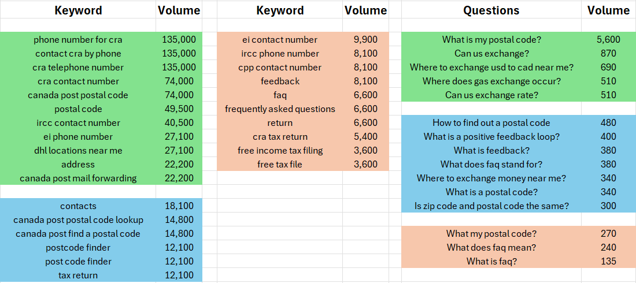

The site firstly have big header image stating FAQ but in the page they don’t have faq in help center. And then they have contact information and exchange information. So, according to to me first in help center page they should have contact information like address of company, including map with attractive div. Contact details should include full address with map, email address, mobile number of company and name of cities where they deliver products. It should be descriptive not like image below. It should have lets connect heading and below they should have address information. With that they must have a form for receiving the customer feedback.

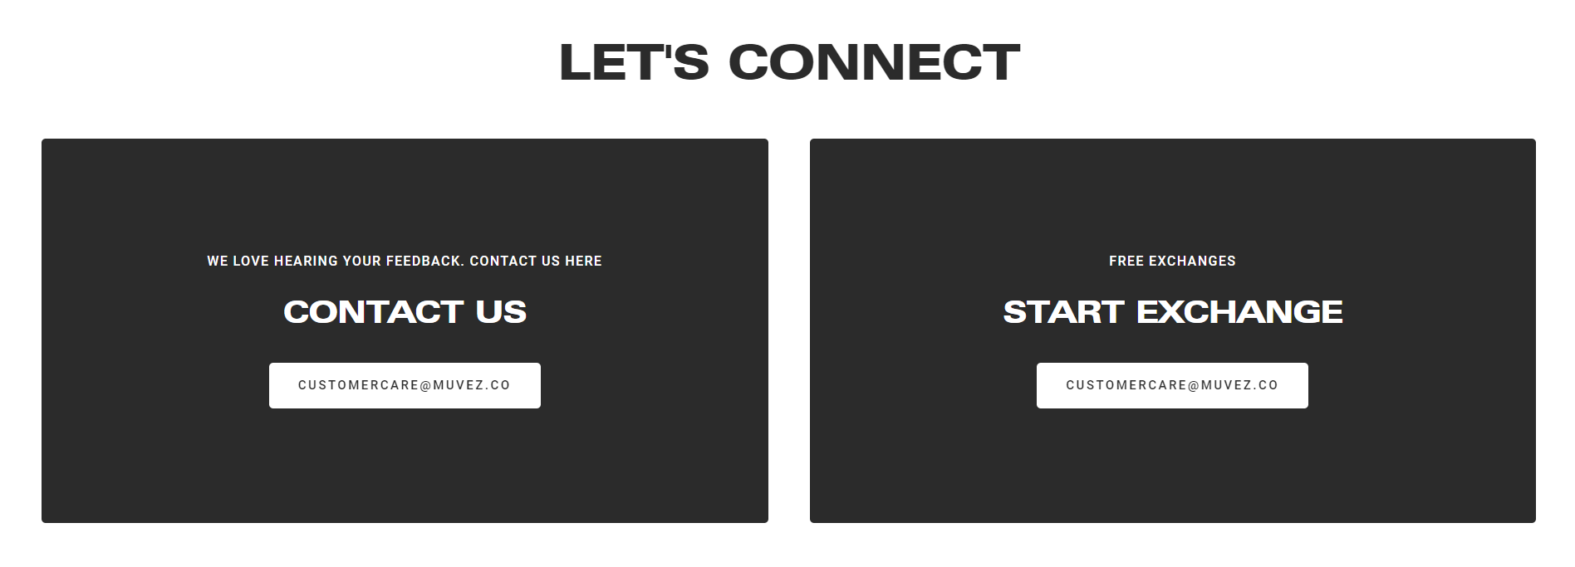

Then they should have section with “Free Exchange” title and a little bit content like “How our exchange process works is out representative will reach to your address and will pick up the product and will ask for confirmation code received in your registered email address. After verification they will collect the old product and will provide you with brand new shoes you like to receive in exchange of old shoes. If there is difference in money you need to give the money to our representative.” Then it should have a small video demonstrating the same process through graphics.

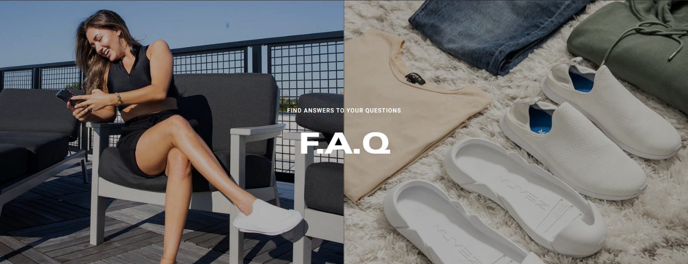



Then at last they should have F.A.Q.s section like image mentioned above. This section must have multiple questions and answers like they should also include questions I mentioned above which has high volume and with that they can have questions and answers from men, women and kids+women products page which have small FAQ section at bottom.

* **Conclusion:**

Concluding the assignment, I can say that there were some major as well as minor changes in the site including content at many places was not enough, so they must add this content. One major change they need to update site structure because old structure is not appropriate, they must update it with new structure I mentioned earlier at top. And it should use trending keyword like I mentioned above for these 8 pages.

* **References:**

Keyword Excel file: <https://docs.google.com/spreadsheets/d/1SM-a-LLooH4huJnLQwsm0IxyF_9wgo-z/edit?usp=drive_link&ouid=115837468861613706242&rtpof=true&sd=true>

Tools used for keyword research:

* 1. <https://www-ca.spyfu.com/keyword/overview>
  2. <https://www.wordstream.com/keywords>
  3. <https://www.semrush.com/analytics/keywordmagic/start>